2024 JC2 H2 GEOGRAPHY Preliminary Examination
Paper 2 Suggested Answers

1a) Explain a suitable hypothesis for the students’ fieldwork investigation. [4]

Award 1 mark for the suggestion of a suitable hypothesis.
Award 1 mark for each explanation of why the stated hypothesis is suitable, to a maximum of 3 marks.
Award a maximum of 1 additional mark for further development of each explanation, where applicable.

Possible responses include:
“Elderly residents in Bukit Merah View aged 65 and above find the Silver Zone features useful in making Bukit Merah View more accessible”
- This hypothesis is specific in defining the target group of the elderly.
- The scope of the investigation as defined is also feasible given the time frame, resources and expertise of the students participating in the fieldwork.

1b) Explain three safety considerations the students should have planned for in their fieldwork. [6]

Award 1 mark for each safety consideration to a maximum of 3 marks.

Award 1 mark for each explanation of how potential safety risks may be mitigated, to a maximum of 3 marks.
Award a maximum of 1 additional mark for further development of each explanation, where applicable.

Possible responses include:
- Risk of working adjacent to the roads where they might be vulnerable to traffic hazards like fast moving vehicles.
  - They should thus plan for this by choosing to stand as far away from the road as possible.
- Risk of interacting with strangers and risk of harassment from undesirable characters.
  - Students should work in pairs or small groups, with their mobile phones ready at all times so as to call for help when needed.
- Risk of poor weather
  - Students could have consulted the weather forecast and be prepared with umbrellas or raincoats to mitigate against weather effects.

1c) Citing data from Resource 1 and the preamble, explain how the students’ data collection method could be improved. [6]

Award 1 mark for each area for improvement in the data collection methodology, to a maximum of 3 marks.

Award 1 additional mark for further development of each suggestion, where applicable.

Possible responses include:
The preamble states that the students timed their fieldwork sessions at the same timing on weekday afternoons between 3pm and 7pm across all three sessions.
- One criticism of this is that it provides a limited window of access the students have to the entire target group of elderly residents at Bukit Merah View.
- They could have planned it such that they could carry out their fieldwork in the morning for one of their sessions and on a weekend to avoid clashes with their school timetable.

- Another area of improvement has to do with the interruption from stormy weather. This likely impacted the sample size the students were able to get responses.
- This could have been prevented if they made the decision to postpone their third session.

- Group B’s site is confined to a small stretch of road and this is limits their access to potential respondents.
- As seen in Resource 1, the area of implementation of the Silver Zone features extends to a much larger area. Group B should have traversed the entire boundary of this area to improve their chances of getting more responses.

1d) Citing information from Resource 3, explain the strengths and limitations of the questionnaire the group designed. [6]

Award 1 mark for each suggestion for improvement, supported by information cited from Resource 2 to a maximum of 6 marks.
Award a maximum of 1 additional mark for further development of each explanation.

Possible responses include:
Strengths
- The questionnaire survey begins with an introduction of the identity of the students as well as their research objectives, which enhances the credibility of the group.
  - The introduction also built in an assuring statement that the collected data would be handled ethically to protect the anonymity of the respondents.
- The use of a rating scale to poll the respondents’ helps to quantify the subjective nature of perceptions.

Limitations
- The questions of the questionnaire asking about age and years of living in Bukit Merah View are open ended.
  - They could have been designed as multiple-choice questions with options.
- The first question asking respondents about their awareness of the Silver Zone features serves little purpose other than to filter out potential respondents from non-respondents since those who answer ‘no’ will not be relevant to the study.
  - On the other hand, the students might have wanted to find out also the level of public awareness of the Silver Zone features which does affect their usefulness and effectiveness.

1e) Using a suitable form of data representation, present the group’s findings as shown in Resource 4. [4]

Award 1 mark for an accurate representation of the data set from Resource 4 to a maximum of 2 marks..

Award 1 mark for an appropriate labelling of the axes in the data representation technique.
Award 1 mark for an appropriate title for the data representation technique.

Possible responses include:

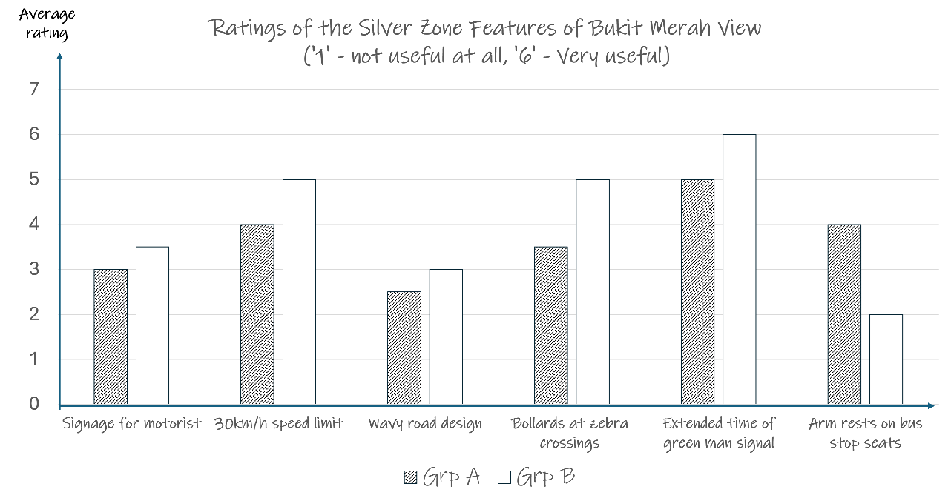

1f) Citing data from Resource 4, compare the findings from Groups A and B. [4]
Award 1 mark for each comparison, supported by information cited from Resource 4 to a maximum of 4 marks.
Award a maximum of 2 marks if only differences or similarities are mentioned.
Award a maximum of 1 additional mark for further development of each explanation.

Possible responses include:

Similarities

The ratings given by respondents from both groups largely match in terms of ranking: Both groups rated ‘extended time for green man signal’ the highest at ‘5’ and ‘6’ respectively, followed by the 30km/hr speed limit, the bollards at zebra crossings, signage for motorists and wavy road design.

Both groups rated the 6 Silver zone features above ‘3’, with only 1 feature rated ‘2.5’ and ‘2’ respectively.

Differences

One exception to the general correspondence between Group A and Group B’s average ratings is for ‘arm rests on bus stop’, which rated better at ‘4’ for group A and only ‘2’ for group B.

Generally speaking, the average ratings for Group A were lower than that from Group B.

1g) Evaluate the usefulness of the group’s fieldwork findings to the class project on understanding the needs of the elderly in Bukit Merah estate. [10]

Possible responses include:

The needs of the elderly in an urban setting encompass the range of environmental, social and economic aspects that affect their quality of life.

The group’s fieldwork focuses on the infrastructural provision of the Silver Zone features which does contribute to a selection of the elderly’s environmental, social and accessibility needs. However, even within this scope there are limitations to their findings that can be supplemented through future research.

Usefulness of the findings
- From Resources 3 and 4, it can be seen that the students gained specific insights into which of the features were more useful than others. This could in turn help uncover which aspects of accessibility and mobility the elderly value more.
- From Resource 4 it seems that features like the extended time of green man signal and 30km/h speed limit were perceived to be the most useful. Conversely, features like arm rests on bus stop seats were rated lowly by respondents in group B, which could suggest that the elderly value road safety more than comfort.

Limitations of the methodology of the project
- From Resources 1, it is apparent that the study area and sampling sites is a small part of Bukit Merah.
- A useful extension of the study of accessibility needs would be a comparative study of the perceptions of accessibility and safety for elderly in other parts of Bukit Merah and comparing their perceptions gathered in this fieldwork study.

In investigating accessibility needs, a perception survey may only paint a partial picture. Other fieldwork methods collecting other forms of relevant data could enrich the findings.

Limitation of the findings in the context of the class project on elderly needs
As mentioned earlier, the needs of the elderly are diverse and extend beyond accessibility and sense of safety. Hence, the findings from this group would contribute just a part to the bigger picture of elderly needs that the class project might be working towards.
- For example, the social needs of the elderly can be investigated by studying topics such as social isolation and loneliness.

Levels marked:

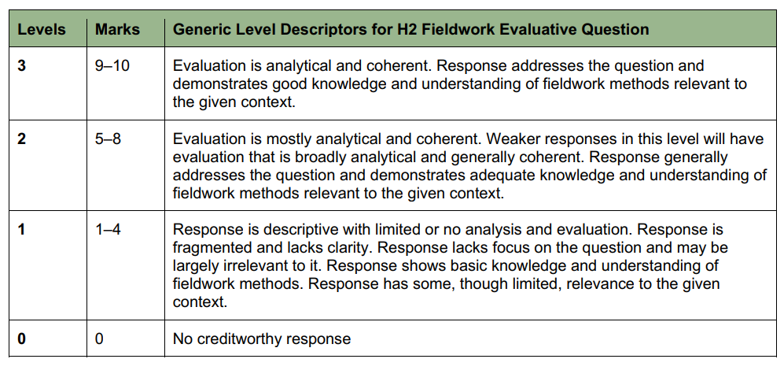

- Resource 5 shows the global temperatures since 1880 as compared to the average global temperature for the mid-20th century years of 1951-1980. Resource 6 shows a simplified schematic representation of the greenhouse effect. Resource 7 shows information about the ecological footprint, Human Development Index (HDI) and Happy Planet Index in selected countries for 2016. Resource 8 is a table showing information about the ecological footprint, population and GNI per person data for selected groups of countries.

2a) With reference to Resource 5, explain the possible effects of global temperature changes on aquatic and terrestrial ecosystems. [8]

Award 1 mark for each explanation of the effects of global warming on aquatic ecosystems, to a maximum of 4 marks.
Award 1 mark for each explanation of the effect of global warming on terrestrial ecosystems, to a maximum of 4 marks.
Award a maximum of 1 additional mark for further development of each explanation, where applicable.

Possible responses include:
From Resource 5, it can be observed that global temperatures have been higher and are rising at an increasing rate in recent decades compared to the middle of the 20th century (1951-1980).
Rising global temperatures commonly translates to increased water temperatures in oceans, lakes, rivers and streams. This can affect the behaviour of aquatic species and can disrupt the distribution of plant and animal species in aquatic ecosystems.
Rising global temperatures also often modify the amount and quality of habitat for aquatic plants and animals and influence the ecosystem’s productivity and diversity.
Similar to the aquatic ecosystem, global warming can alter the biodiversity of terrestrial ecosystems as plant and animal species face challenges in adapting to rapidly changing environmental conditions.

2b) Explain the limitations of Resource 6 as a source of information about the greenhouse effect. [3]

Award 1 mark for each explanation of a limitation of Resource 6, to a maximum of 3 marks.
Award a maximum of 1 additional mark for further development of each explanation, where applicable.

Possible responses include:

The lack of a scale and the absence of figures to quantify the amount of energy exchange between the incoming solar radiation and outgoing longwave radiation can be limiting.

Resource 6 does not show where the greenhouse gases originate – whether they are from natural or anthropogenic sources.

The incoming solar radiation is not labelled as short-wave radiation although the outgoing radiation is labelled as longwave radiation.

2c) Explain how human activities have accelerated global temperature changes through positive feedbacks. [6]

Award 1 mark for each explanation of how an example of a human activity can contribute to global warming, to a maximum of 3 marks.
Award 1 mark for each explanation of a positive feedback loop that accelerate the process of global warming, to a maximum of 3 marks.
Award a maximum of 1 additional mark for further development of each explanation, where applicable.

Possible responses include:
For example, the burning of fossil fuels to power industries, especially in the rapidly industrialising economies releases large amounts of CO₂ and other greenhouse gases.
These greenhouse gases create the enhanced greenhouse effect.
With the heightened global temperatures, a positive feedback may be created to cause global temperatures to rise even further.
For example, the melting of permafrost, snow, glaciers and sea ice due to rising global temperatures will reduce the albedo of the planet.
The melting of the world’s permafrost can also expose much of the previously locked up minerals and plants and animal remains to weathering and decomposition processes.

2d) Cite data from Resource 7 to describe the relationships shown. [5]

Award 1 mark for description of each valid identified relationship shown in Resource 7, to a maximum of 3 marks.
Award 1 mark for each citing of relevant data to support the identified relationship, to a maximum of 3 marks.
Award a maximum of 1 additional mark for further development of each description, where applicable.

Possible responses include:
There is a clear correlation observed between HDI and the ecological footprint – the higher the country’s HDI the higher the country’s ecological footprint.
For example, the USA has the highest recorded HDI at around 0.93 in 2016. USA also has the third highest ecological footprint recorded at over 9gHa.
In contrast, Burundi has the one of the lowest HDI at around 0.4 and has the lowest ecological footprint shown in Resource 7.
It can also be observed that countries with low numbers on the Happy Planet Index have a low ecological footprint.
For example, Bangladesh is 8 on the Happy Planet Index and has a low ecological footprint of less than 0.5gHa.

2e) Cite data from Resource 8 to describe the variations in ecological footprints between the groups of countries shown. [4]

Award 1 mark for each accurate description in variation in ecological footprints between the groups of countries, to a maximum of 4 marks.
Award a maximum of 1 additional mark for further development of each description, where applicable.

Possible responses include:

The oil producing countries have the highest ecological footprints compared to the other groups of countries.

For example, Qatar has the highest recorded ecological footprint at 11.68gha/person.

In addition, although there were only 3 oil producing countries listed, they have the highest variation in ecological footprints amongst them (3.24). In comparison, the variation amongst the HICs was 2.03 although there were 6 countries included in this group.

2f) With reference to Resources 7 and 8, explain why the ecological footprint differs across countries and regions. [4]

Award 1 mark for each relevant explanation, to a maximum of 4 marks.
Award a maximum of 1 additional mark for further development of each explanation, where applicable.

Possible responses include:

The ecological footprint differs across countries and regions due to a variety of factors such as variations in population sizes, differences in levels of development and consumption and the nature of the available technology.

For instance, Resource 8 shows that oil producing countries have the highest records of ecological footprint. This is partly because extracting, refining and processing oil consumes significant amounts of energy and generate large amounts of greenhouse gas emissions.

Compared to the rural regions, cities today have huge ecological footprints.

This is because cities source many of the materials that they consume from way outside of their immediate geographical hinterlands and produces much waste and pollution.

3. Evaluate the impact of urban reimaging on sustainable urban development. [20]

Sustainable urban development seeks to create cities that are environmentally responsible, socially equitable, and economically viable over the long term.

Due to the offshoring of manufacturing activities from the developed world to the emerging economies, many cities in the developed countries have experienced the ill-effects of deindustrialisation and inner-city decay. As such, these cities have subsequently suffered from poor image problems and needed to engage in various urban reimaging campaigns.
- Urban reimaging refers to attempts by the urban authorities to purposefully reconfigure and change the image of a city and the way people view it.
- It often involves making physical changes to the built environment designed to modernize and make urban spaces better places to live, work and visit.

Through the examination of two case studies, this essay aims to evaluate the impact of urban reimaging on cities’ pursuit of sustainable urban development.

Possible Points of Discussion:
- Reimaging efforts of London Docklands – evaluate how the project was able to boost the economic vitality of the region.
- Reimaging of Columbo, Sri Lanka – evaluate the efforts by the government at greening the city, improve its overall liveability and environmental sustainability.

- ‘Uncertainties over future impacts of climate change are the greatest impediment to the implementation of effective strategies to respond to climate change.’ Evaluate this statement. [20]
The climate change that our planet currently faces is a consequence of the enhanced greenhouse effect (EGHE).
- Given the current threats posed to the welfare of societies and their future sustainability through the increased incidence of extreme weather events and rising sea levels with a warmer world, it has become necessary and increasingly urgent to respond to climate change through mitigation and adaptation strategies. Through these, the global community may yet avoid the worst consequences of climate change.
- However. while it is fair to say that uncertainties over future impacts of climate change may be the greatest impediment to the implementation of these strategies, we should also acknowledge that other challenges are significant impediments as well.

Possible Points of Discussion:
- Explain the reasons for the uncertainty over future impacts of contemporary climate change: lack of full understanding of physical processes; incomplete in-situ data on vast expanses of oceans, deserts and polar regions; uncertainty over future greenhouse gas emissions.
- Economic challenges including the use of renewable and alternative energy, including nuclear energy, to provide energy security while mitigating climate change.
- Political challenges can also arise when a new administration, with very different national priorities, takes over the governing of a country.

Levels marked:

